Half t distribution

Def

A special case of folded non-standard t distribution $$E\left[X\right]$$ = $$0$$

PDF

$$f\left(x;k\right)$$

= $$2⋅\frac{1}{{\left(k⋅pi\left(\right)⋅std\left(x\right)\right)}^{\frac{1}{2}}}⋅\frac{Gamma\left(\frac{k+1}{2}\right)}{Gamma\left(\frac{k}{2}\right)}⋅{\left(1+\frac{1}{k}{\left(\frac{x}{std\left(x\right)}\right)}^{2}\right)}^{−\frac{k+1}{2}}$$

for all $$x≥0$$

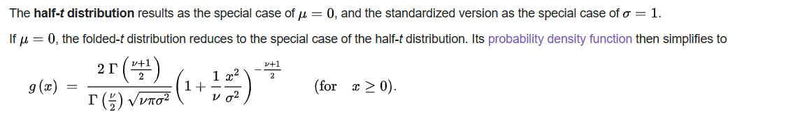

CDF

By the relationship bewteen PDF and CDF, we have that

$$F\left(x;k\right)$$

= $$integral\left(f\left(t;k\right)dt,t=−inf,t=x\right)$$

Expected Value

It is undefined for 1th moment.

For higher moments (moments that greater than 1), see moments section.

Variance

It is undefined for 1th and 2th central moments.

For higher central moments (moments that greater than 2), see central moments section.

Moments

$$m_{k}\left(X\right)$$

= $$2⋅std\left(X\right)⋅{\left(\frac{k}{pi\left(\right)}\right)}^{\frac{1}{2}}⋅\frac{1}{k−1}⋅\frac{Gamma\left(\frac{k+1}{2}\right)}{Gamma\left(\frac{k}{2}\right)}$$

for all $$k>1$$ and $$k$$ belongs to integer.

Central Moments

$$CM\left(X;k\right)$$

= $$std{\left(X\right)}^{2}⋅\left[\frac{k}{k−2}−\frac{4}{pi\left(\right)}⋅\frac{k}{{\left(k−1\right)}^{2}}⋅{\left(\frac{Gamma\left(\frac{k+1}{2}\right)}{Gamma\left(\frac{k}{2}\right)}\right)}^{2}\right]$$

for all $$k>2$$ and $$k$$ is an integer.

Ref

[Folded-t and half-t distributions - Wikipedia](https://en.wikipedia.org/wiki/Folded-t_and_half-t_distributions)